Service Level Agreement Contract
Technical Document
PIA Technical Review
12/02/2018

Contents
2. Introduction 3
3. Ubuntu Server 17.10 Installation 3
3.1 Update your server 3
3.2 Configure IP address as static and check the gateway information 4
3.3 Install Ubuntu desktop 5
3.4 PIA –Back Installation 6
3.5 Installation of POSTGRESQL 6
3.5.1 Check version postgres 6
3.5.2 check client version 7
3.5.3 Install version postgres 7
3.5.4 Check install postgres 7
3.5.5 Install posgresql with Password (best practice) 8
3.6 Roles creation 8
3.6.1 Prod User & Role Creation (useradmin) 8
4. RAILS 5.0.x - RUBY 2.3.x - mode.js 9
4.1 GNUP Key 9
4.2 RUBY 2.3.1 9
4.3 RAILS 5.0.6 10
4.4 Node.js 11
4.4.1 Check the versions 11
5. piaback : Installation 11
5.1 Fill out the DB information 12
5.2 Install all dependencies 12
5.3 Fill out the secret keybase 12
5.4 piaback : Configuration 12
5.4.1 DEV (Same for test just change the Environment name) 12
5.4.2 Prod 13
5.5 piaback : Test the application 13
6. PIA Front : Installation 14
6.1 Install pre-requisite 14
6.2 Build the Production Environment 14
6.3 Run the Front Server 15
7. Configure PIA tool 15

Introduction

PIA Application is a suite of front and back end servers using Ruby on Rails and Angular JS.
This application is an open source application that you can find with all relevant information in the below link: https://github.com/LINCnil

Ubuntu Server 17.10 Installation

Update your server
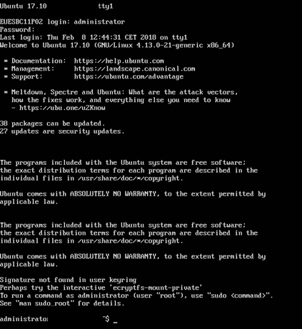
Update the package with the command
Sudo Apt-get update
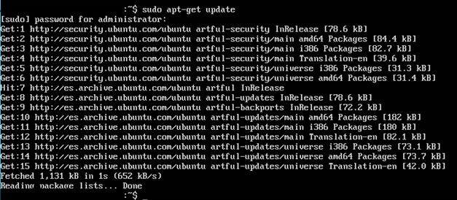

Configure IP address as static and check the gateway information
ifconfig -a | grep eth

To verify the IP address configuration of eth0, you can use the ifconfig command in the following manner.
ifconfig eth0
eth0 Link encap:Ethernet HWaddr 00:15:c5:4a:16:5a
inet addr:10.0.0.100 Bcast:10.0.0.255 Mask:255.255.255.0
inet6 addr: fe80::215:c5ff:fe4a:165a/64 Scope:Link
UP BROADCAST RUNNING MULTICAST MTU:1500 Metric:1
RX packets:466475604 errors:0 dropped:0 overruns:0 frame:0
TX packets:403172654 errors:0 dropped:0 overruns:0 carrier:0
collisions:0 txqueuelen:1000
RX bytes:2574778386 (2.5 GB) TX bytes:1618367329 (1.6 GB)
Interrupt:16
To configure a default gateway, you can use the route command in the following manner. Modify the default gateway address to match your network requirements.
sudo route add default gw 10.0.0.1 eth0
To verify your default gateway configuration, you can use the route command in the following manner.
route -n
Kernel IP routing table
Destination Gateway Genmask Flags Metric Ref Use Iface
10.0.0.0 0.0.0.0 255.255.255.0 U 1 0 0 eth0
0.0.0.0 10.0.0.1 0.0.0.0 UG 0 0 0 eth0
If you require DNS for your temporary network configuration, you can add DNS server IP addresses in the file /etc/resolv.conf. In general, editing /etc/resolv.conf directly is not recommanded, but this is a temporary and non-persistent configuration. The example below shows how to enter two DNS servers to /etc/resolv.conf, which should be changed to servers appropriate for your network. A more lengthy description of the proper persistent way to do DNS client configuration is in a following section.
nameserver 10.34.1X.X
nameserver 10.34.1X.X
If you no longer need this configuration and wish to purge all IP configuration from an interface, you can use the ip command with the flush option as shown below.
ip addr flush eth0

Install Ubuntu desktop
sudo apt-get install ubuntu-desktop

Restart the server
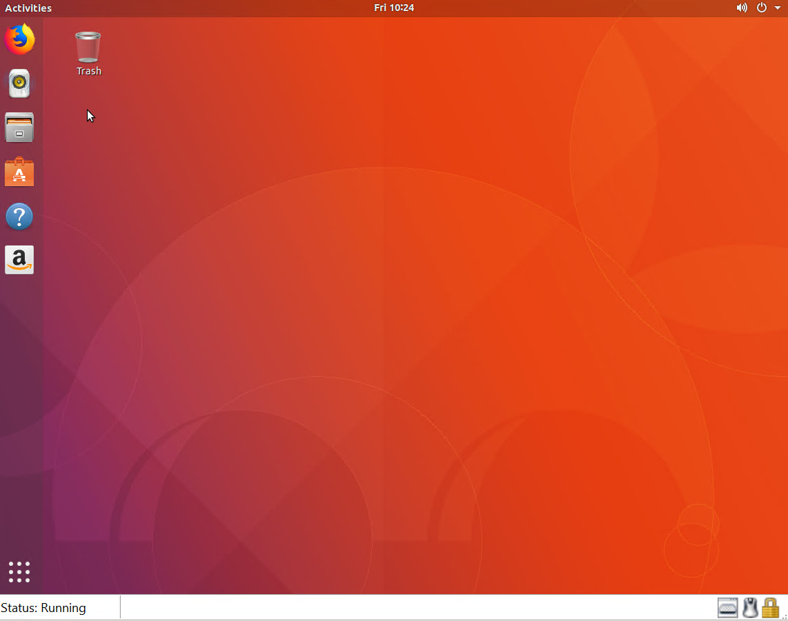

PIA –Back Installation
Check where you are in the directory and check the postgresql install that you have
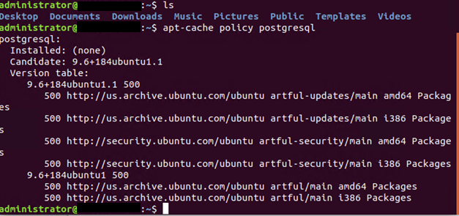
Useful Links
# How-to : install pia-back
https://github.com/LINCnil/pia-back
# How-to : install postgres
https://help.ubuntu.com/community/PostgreSQL
# How-to : install rail 5.1 et ruby 2.3.1
http://rubyonrails.org/

Installation of POSTGRESQL

Check version postgres

apt-cache policy postgresql

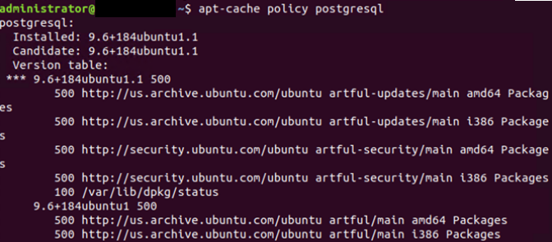

check client version
apt-cache policy postgresql-client

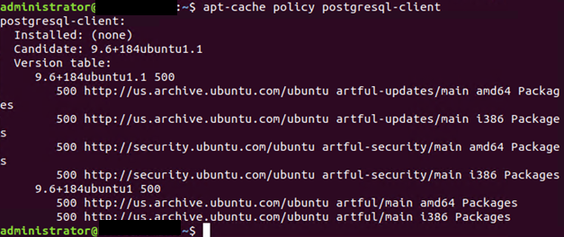

Install version postgres
Sudo apt-get install postgresql postgresql-client –y
Sudo apt-get update && apt-get install -y procps

Check install postgres
ps -ef | grep postgre

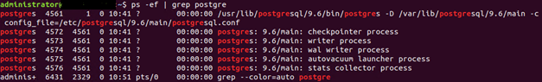

Install posgresql with Password (best practice)
su – postgres

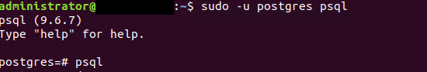
To exit the psql console just use the command \q

Roles creation

Care : Depending of the installation you want to make (Dev/Test or Prod)
I recommend to create the Prod environment only on prod server and without Dev Test to avoid miss configuration.
For Dev/Test, I recommend to create it in dev test server without the production environment.
To make sure those environment are created properly, you need to adapt the database.yml that you will configure with the DB access you will create below
- Each users need to have DB creation access for each correspondent base « prod » « dev » and « test »

Prod User & Role Creation (useradmin)
Sudo su - postgres
createuser --interactive –P
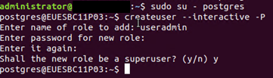
Super-user ? (y/n) : Y
Ctrl D to go out from this account

RAILS 5.0.x - RUBY 2.3.x - mode.js

GNUP Key
apt-get install curl –y
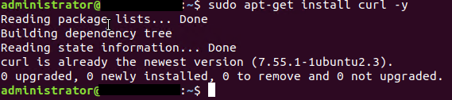
gpg --keyserver hkp://keys.gnupg.net --recv-keys409B6B1796C275462A1703113804BB82D39DC0E3
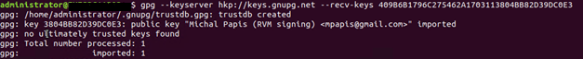
\curl -sSL https://get.rvm.io | bash -s stable
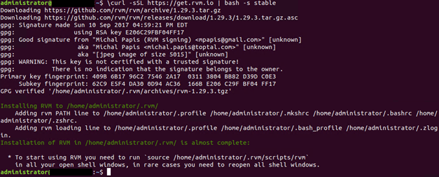

RUBY 2.3.1
source /etc/profile.d/rvm.sh (if doesn’t work … check the source )
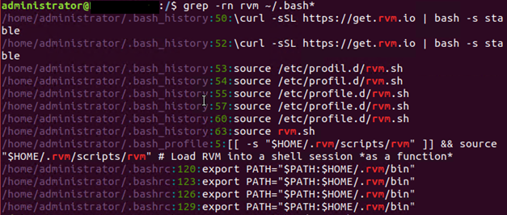
rvm install 2.3.1
rvm use 2.3.1 --default

RAILS 5.0.6
The last version is 5.1.4 but requierement is 5.0.x ...
gem install rails --version 5.0.6
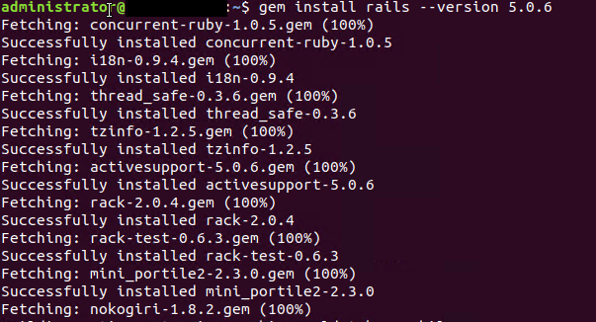

Node.js
apt-get install nodejs -y

Check the versions

apt-cache policy ruby
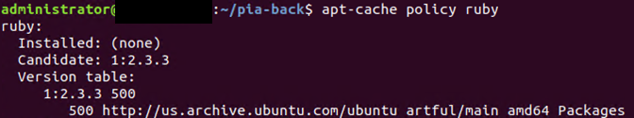
whereis ruby
ruby -v
apt-cache policy rails
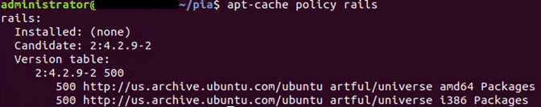
whereis rails

piaback : Installation
Run the following command as admin or with sudo
Sudo apt-get install git -y
git clone https://github.com/LINCnil/pia-back.git
cd pia-back
cp config/database.example.yml config/database.yml

Fill out the DB information
if you only have Prod env, just fill out Prod, Dev and test need to be fillout the same way
vi /root/pia-back/config/database.yml

Install all dependencies

cd piaback
Sudo apt-get install libpq-dev
Sudo bundle install

Fill out the secret keybase

You need to get your secret key baserake to copy it inside application config
Sudo echo "SECRET_KEY_BASE: $(rake secret)" | sudo tee /root/pia-back/config/
application.yml
You can also putting the key manually as soon as we use the Ubuntu desktop. To get the key use the following command and copy past on the application.yml (pia-back/config)
RAILS_ENV=production rake secret

piaback : Configuration

DEV (Same for test just change the Environment name)

Create database
bin/rake db:create

Create tables
bin/rake db:migrate

Create Environment
RAILS_ENV=development bin/rake db:migrate

Run the application (test)
bin/rails s

Run the application (dev)
RAILS_ENV=development bin/rails s

Prod

Create database
RAILS_ENV=production bin/rake db:create

Create tables
RAILS_ENV=production bin/rake db:migrate

Run the application
RAILS_ENV=production bin/rails s

piaback : Test the application

Bin/rails s -b 10.34.10.253 -p 8080
If you use the URL you should see a PIA Icon like below :

PIA Front : Installation
On home directory
git clone https://github.com/LINCnil/pia.git

Install pre-requisite
cd pia
Sudo apt install npm
Sudo npm install -g @angular/cli

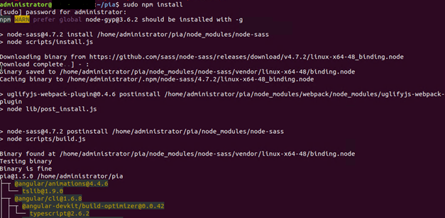

Build the Production Environment

sudo ng build prod
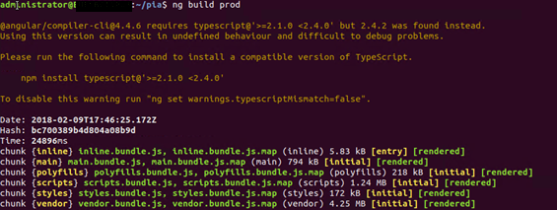

Run the Front Server
Ng serve –e prod –host 10.34.10.XXX –port XXXX
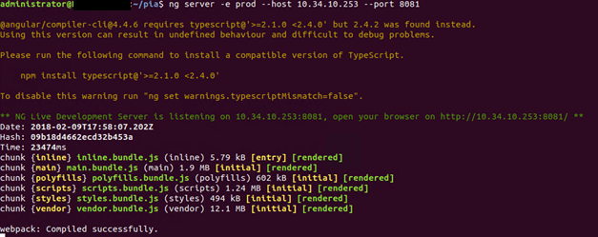

Configure PIA tool
Use the URL and Port you configure on the Front server, here it’s 10.34.10.XXX:XXXX
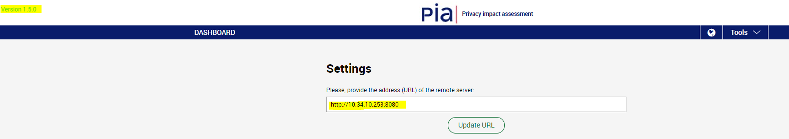
If you are running a prod version you should see like below the version, if not it should mention “Development” or “Tests”
Put on Tools >> Settings the PIA Back URL that you configure on step 5.5.
If you have stand alone user of Pia App, you need to do the same to have every user using the Back End Database.
If you have any question please check the PIA Github.

